EXPT NO:5 | DASHBOARD DESIGNING
DATE: 24.01.2026

PRE-LAB QUESTIONS
- How do dashboards support strategic decision-making?
Ans - Dashboards present key information visually, helping decision makers quickly understand performance, trends, and issues to take timely actions.
- What role do dashboards play in AI monitoring systems?
Ans - Dashboards help monitor AI system outputs, performance metrics, and anomalies in real time, ensuring the system works correctly and efficiently.
- Why is interactivity essential in modern dashboards?
Ans - Interactivity allows users to filter, drill down, and explore data, making analysis more flexible and user specific.
- What cognitive overload issues exist in dashboards?
Ans - Too many visuals, colors, or metrics can confuse users and make it hard to focus on important information.
- How are KPIs derived from raw data?
Ans - KPIs are created by processing raw data using calculations like averages, counts, or percentages to represent key performance measures.
OBJECTIVE: To design an interactive analytical dashboard for monitoring key metrics.
SCENARIO: An AI-based smart campus system requires a dashboard to monitor attendance, academic performance, and resource utilization in real time.
IN-LAB TASKS (Using PowerBI)
• Design KPI cards for attendance and performance
• Implement filters by department and semester
• Link multiple views for drill-down analysis

OUTPUT:
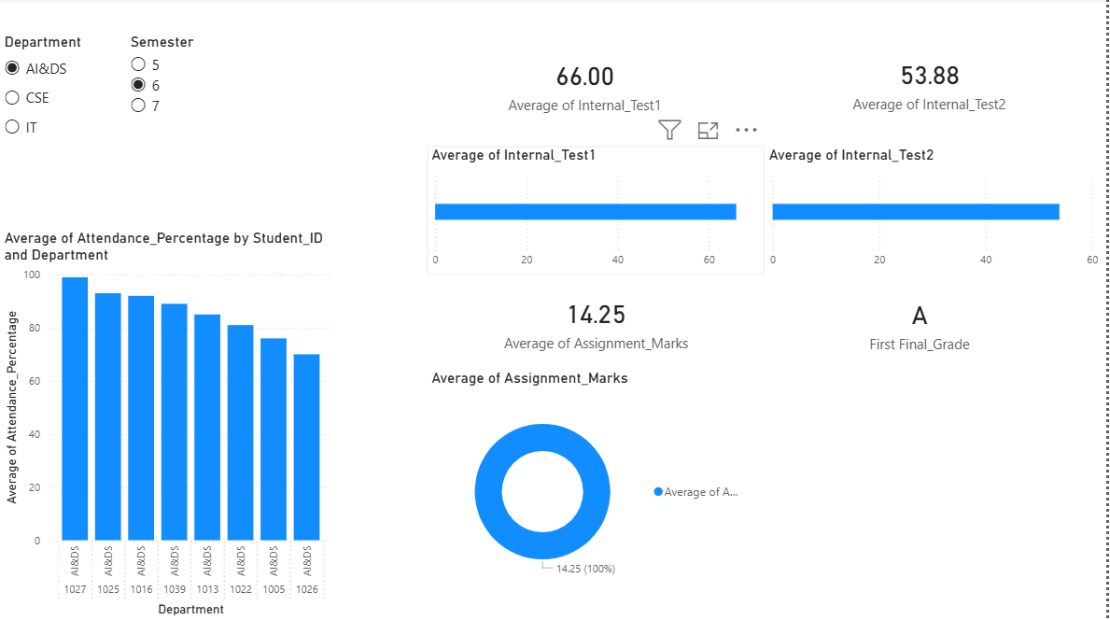

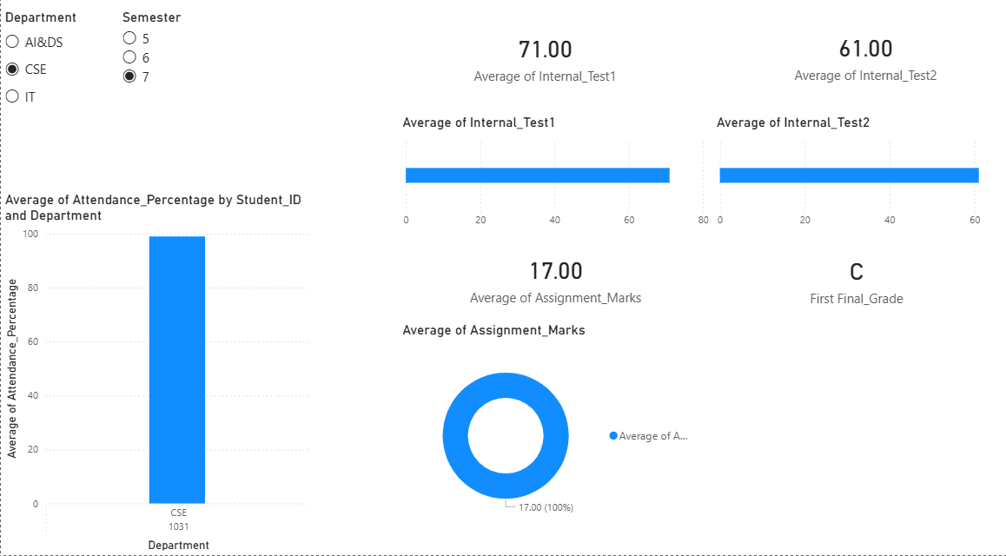

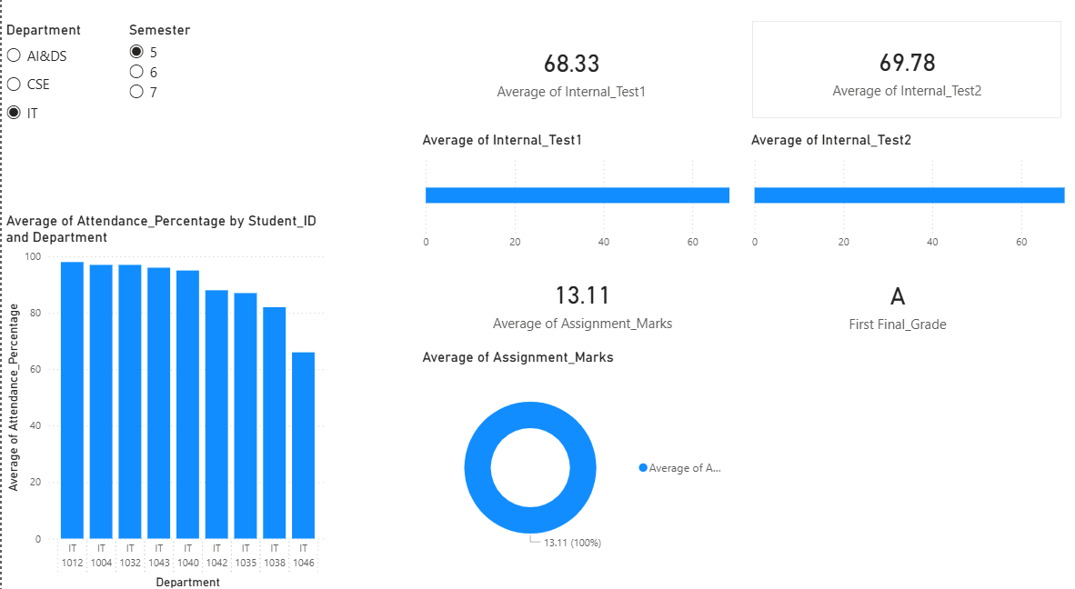

POST-LAB QUESTIONS

- How does interactivity improve analytical depth?
Ans - Interactivity allows filtering by department and semester and drill-down to student level, helping analyze performance in more detail.
- Which KPIs are critical for academic monitoring?
Ans - Average attendance percentage, internal test scores, assignment marks, and final grades are critical KPIs for monitoring student performance.
- What design principles prevent information overload?
Ans - Average attendance percentage, internal test scores, assignment marks, and final grades are critical KPIs for monitoring student performance.
- How can dashboards be integrated with AI alerts?
Ans - Average attendance percentage, internal test scores, assignment marks, and final grades are critical KPIs for monitoring student performance.
- How do dashboards enhance transparency in institutions?
Ans - Dashboards provide clear and real-time visibility of academic performance, making data accessible to faculty and administrators.

LEARNING OUTCOME: Students understand dashboard design for AI-driven environments.
ASSESSMENT
Description | Max Marks | Marks Awarded
Pre Lab Exercise | 5
In Lab Exercise | 10
Post Lab Exercise | 5
Viva | 10
Total | 30
Faculty Signature

